Clun Memorial Hall and Playing Fields
Clun Space AONB Project:
Audit Report
(Recommendations in separate document)

Contents
Page
- Project context
2 Project aims
- Site description, including Map of areas (Fig 1)
6 Distinct areas
9 History and heritage of the site, including historic Map (Fig 2)
11 Hazards, constraints and threats

(Please note: all documents and evidence referred to in this Report and Recommendations are available as separate documents by contacting the Secretary of Clun Memorial Hall Committee.)

Date (from/to) | May 2018 – March 2019
Date of review | To be agreed
Owner/tenant | Clun Memorial Hall and Playing Fields, Registered Charity No. 507032
Agent/contact | Angela Martin, Secretary Clun Memorial Hall Committee, Telephone: 01588 640017
Ownership rights and agreement to public availability of the plan | The land is in the freehold ownership of Clun Memorial Hall and Playing Fields.  This work is part of the Clun Space Project funded by the Shropshire Hills AONB Conservation Fund. It was managed by the project steering group report which is accountable to the Memorial Hall trustee committee.

The Project – some context
The aim of this project has been to assess and record the features of the area of land around the Memorial Hall, owned and managed by the Clun Memorial Hall and Playing Fields charity. The purpose being to update knowledge and information about the area, explore and suggest ways it can be managed and cared for and how it can engage and be made accessible to people in the community, of all ages and abilities, to a greater extent than at present.
The Project has made progress towards this: this report is intended to detail this progress and help direct next steps.

The constitution of the Clun Memorial Hall and Playing Fields Charity states that: “the object of the Charity shall be the provision and maintenance of a village hall and recreation ground for the use of the inhabitants of the Parish of Clun and the neighbourhood thereof … without distinction of political, religious or other opinions, with the object of improving the conditions of life of the said inhabitants.”

Building upon the Charity’s purpose and aims, and considering the legal and societal changes that have occurred in the 27 years since the constitution was written, there is now a wider and more inclusive vision for the future of the land around the Memorial Hall:

The land surrounding Clun Memorial Hall provides an accessible, high quality and sustainable open space, which ensures that the social, environmental and economic benefits of the site are maintained and enhanced for current and future generations of our community. It is both an amenity for the recreation of people and a breathing space for wildlife. The site has an aesthetic and cultural value that is difficult to quantify, but formal and informal use of the site by local residents and visitors of all abilities contributes to the health and wellbeing of our community. The site is managed to maintain and enhance its amenity value, natural capital and ecological value whilst acknowledging and promoting the site’s heritage. The Management Committee of the site work in partnership with local residents and organisations to improve and protect the site for people, whilst balancing this with the needs of local wildlife and the wider environment.

Location
Nearest town, village or feature | Clun Memorial Hall and Playing Fields, Guilden Down Road, Clun, Craven Arms, Shropshire, SY7 8NY
Grid reference | SO302811
Total area (ha) | 2.8 ha

Project aims

- To commission and gather evidence of a high quality about the biodiversity, heritage, history, current use and barriers to use of the Memorial Hall land, sometimes known as ‘The Park’.
- To produce an audit based on the above that will enable recommendations to be made for a management plan and framework for the Memorial Hall Committee to care for and develop the area.
- To make recommendations about how we can maintain and develop a community asset that people of all ages enjoy, feel proud of and can be involved with in a variety of ways – monitoring wildlife, learning through events and possibly Forest Schools, via an accessible walking trail, and just as a tranquil place to explore and enjoy.

This project began with an audit carried out from May to December 2018. The audit involved Project Manager Gary Cowell, the Project Steering Group, local individuals, specialist advice and research and young people from the Bishop’s Castle Community College. The audit commissioned a formal botanical study by Fiona Gomersall of Shropshire Wildlife Trust and worked with local people with an interest and expertise in the subject areas covered by the audit.
This process unearthed new information and perspectives on the site and inspired people to find out more.

This report looks at 5 headings, with recommendations for each.

- The Memorial Hall and Land
- Access and land uses
- Biodiversity and distinct areas
- Heritage
- Risk factors

The recommendations have been made with consideration of the financial limitations of the Charity. Many of the recommended actions can be achieved at little or no cost, especially if there is voluntary assistance from local residents. Other actions will have a cost but are necessary, for example tree safety surveys. Some actions will require fundraising and/or grant applications. It is intended to seek funding incrementally, as required.

The Memorial Hall and Land – Site description

The Park is within the Shropshire Hills Area of Outstanding Natural Beauty (AONB). The surrounding landscape consists of arable land, improved lowland pasture, rough grazing uplands and wooded hillsides (both broadleaf woodland and conifer plantations). The site falls within the Shropshire Hills Higher Level Stewardship Target Areas (England). To the east of the site there is a continuation of some tree cover along Guilden Down Road and approximately half of the southern boundary abuts private gardens. The other main amenity site in the vicinity is Clun Castle grounds, managed by English Heritage. The site includes part of what is thought to be the medieval town boundary walls and is the former site of a medieval fish pond, lake and mill stream. The Clun Memorial Hall and playing Fields Charity has created a playground, hard court and a football pitch and increased tree planting along the boundaries.

The site accounts for a wide variety of land uses, from the Hall itself and surrounding hard surfaces, to more naturalistic features such as hedge, field margin and tree cover around the fringes of the site.
See document fig. 1 Map Showing main land use elements of the site.

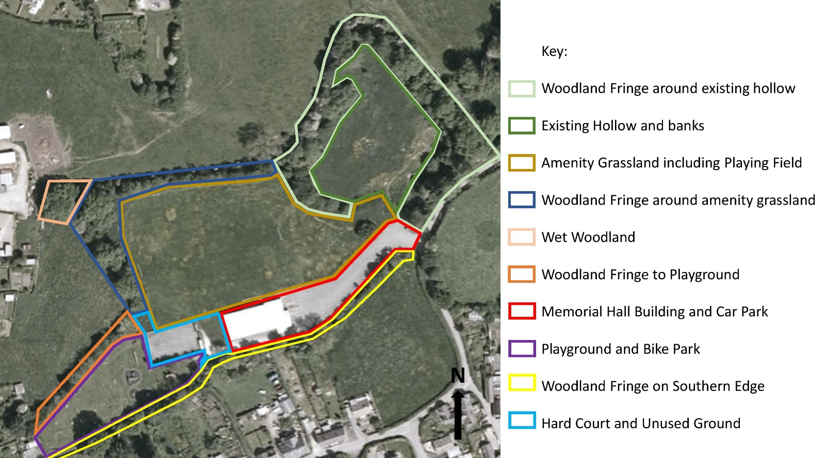

The central area, consisting of around one third of the site at .85ha, is the playing field/amenity grassland. The Hall itself and car park occupy 0.27ha of the southern central area. The hard court and an area of unused land between the hard court and the hall occupies 0.1ha to the west of the hall. The western-most part of the site is occupied by a children’s playground and bike park extending to 0.24ha. The easternmost part of the site is woodland fringe around a hollow (the last part of the former lake) filled with rough vegetation. The only significant gaps in trees are the car park entrance and the western end of the bike park. The thickness of this woodland fringe varies from single trees to the more wooded area at the eastern end of the site. Each part of the site is identified and described in more detail below.

Access and uses
This report acknowledges the access audit of March 2016 by W Fortnam and a report carried out by Memorial Hall committee member, Sally Tudor, in October 2018 to review the Hall’s compliance with the Disability Discrimination/ Equality Act 2010.

The area is used by walkers, dog walkers and occasional formal and informal sports activities such as football and rounders. The area is not accessible to people with buggies, wheelchairs or mobility scooters. The area is tarmac-ed in the carpark and to the side of the hall and the hall has disabled access, but moving west the path fizzles out and is difficult to negotiate in wet/icy weather for anyone. The accessible toilet is not accessible for wheelchair users and does not comply with standard requirements (fundraising is currently under way to address this).

The area is a quiet space and unusually for Clun is flat, so can be used by walkers for health and can be incorporated into longer walks. The playground is a safe place for children to play. There are bins for dog waste and there is commitment from the Committee to enforce their use. The site has been used as a venue for the Green Man Festival and Clun Carnival when the Castle site is too wet. The carpark is used in support of larger events in Clun. It has small, designated accessible parking spaces in need of updating.

Biodiversity

Designated Areas | Map No. | In Site | Adjacent to site
Areas of Outstanding Natural Beauty (AONBs) | n/a | Yes | Yes
Local Nature Reserves (LNRs) | n/a | No; see below | No
Tree Preservation Orders (TPOs) / Conservation Area (CA) | No | No | Yes
The site falls within the Shropshire Hills AONB but there are no other designations on the site. Shropshire Council confirmed by email on 24th September 2018 that there are no Tree Preservation Orders on the site. The southern and western edges of the site border the Clun Conservation Area as can be seen in Figure 1, so any work on trees on this part of the site must be carried out in consultation with the Natural Environment Team at Shropshire Council.

Trees
The Tree Officer who deals with Clun area is:
Dougald Purce
Telephone: 01743 254616
Email: trees@shropshire.gov.uk

In circa 2005 a tree survey was carried out for which each tree was numbered and marked with an aluminium tag. A further survey was carried out in September 2007 by AGS Land Management Limited of Leominster resulting in a comprehensive report in which a number of management recommendations were made. The recommendations considered tree safety, the use of the site and the health of the trees and were ranked according to the risk factors involved.

A review of the 2007 survey by AGS Land Management was carried out on the 7th to 11th January 2018 by Ros Patching and Gary Price-Hunt. The area surveyed stretched from Guilden Down lane hedgerow at the eastern end of the grounds to the end of the play area/bike park along the northern perimeter. It included the trees adjacent to the carpark on the southern side, but not the trees along the footpath towards Clun Castle at the foot of Newport Street gardens.

The main observations from the 2018 review were:
- There was no map or plan with the 2007 survey and the 2005 numbering system did not always seem straightforward or entirely inclusive, making it difficult sometimes to recognise and locate trees from the 2007 survey. A map was prepared from the observations (available as a separate document) which should help with identification and any future assessments or surveys.
- After 10/12 years of growth and change, many of the tree tags are missing or invisible. This made some detective work necessary. Ten years makes a surprising difference to how a tree looks especially when others around it are missing or have arrived in the last decade, but the surveyors were confident they had accurately identified the majority and noted any significant changes since the 2007 survey.
- A significant minority of the trees listed in 2007 are missing, mainly owing to work carried out repairing and maintaining power lines and/or fence building and repair. This applies particularly to some at the north-western ‘corner’ of the existing hollow and along the southern perimeter of the carpark.
- The varietal range of trees mentioned in the 2007 report is still present throughout the grounds, although the numbers of each type of tree has changed, sometimes more (e.g. Wild Cherry, prunus avium and Aspen Poplar, Populus tremula)) and sometimes fewer (e.g. Spindle, Euonymus europaea and Black Poplar, Populus nigra).
- There is evidence that some hedge has been laid and individual trees coppiced in the past, particularly along the northern perimeter and the outer perimeter of the hollow.
- It is particularly difficult to correspond trees to numbers from the previous surveys along the southern carpark perimeter as many are missing, and others are now growing from coppice stools where they have been cut down because of overhead power lines.

The particular issues identified were:
- The 2007 tree survey was carried out with a view to individual tree management rather than ecosystem management. Many of its recommendations, if carried out, would result in a ‘neater’ area, but with less value for wildlife. As it is, the works have often not been carried out, allowing a more natural cycle of growth and decay to establish.
- In any case there appears to have been a piecemeal approach to managing the trees listed on the 2007 survey. Sometimes recommended works in the report appear to have been carried out, usually where there have been pressing health and safety reasons, or where work to powerlines has taken place. However, work recommended in the report for the health of individual trees does not seem to have been carried out.
- There is evidence around the site that trees have been removed or cut back probably by individuals as a ‘need’ was perceived, for example when instating or repairing fencing or when branches have interfered with the habitual dog walking route around the hollow.

Tree disease: how it will affect the site and what should be done
Tree safety is now a significantly increased consideration as Ash Dieback disease has taken hold. The fungus Hymenoscyphus fraxineus has swept across Europe since being accidentally introduced from its native north-east Asia. The fungus is expected to kill 50% to 90% of the Ash trees in Britain. Given the prevalence of ash on the Memorial Hall land, this will have a significant impact over the next decade. As well as directly killing ash trees, the infection weakens trees so that they are more susceptible to other pathogens such as honey fungus (Armillaria mellea). The general consensus is to retain ash where possible but obviously the condition of infected trees and the risk they may pose to site users may preclude this approach.

In addition to Ash dieback there is a present threat to Alder trees caused by pathogenic Phytophera species of fungus. This is widespread in the Clun valley and present in the grounds of Clun Castle. Planting Alder species would therefore not be recommended, but natural regeneration from existing trees can be permitted. If alder trees on site become infected the recommended management approach is to coppice them 20-30cm above ground and allow the stool to re-shoot. Further information can be found at:
https://www.forestresearch.gov.uk/tools-and-resources/pest-and-disease-resources/phytophthora-disease-of-alder/

Other Flora and Fauna
Healthy varieties of flora and fauna make this a locally important ‘breathing space’ site for biodiversity in an intensively-farmed area.
A formal botanical survey was carried out by Fiona Gomersall of Shropshire Wildlife Trust on 5th July 2018. Informal sightings lists have been provided by 5 local residents involved in natural history.

There is currently a good range of species on the on the site as can be seen in the botanical survey results together with the bird, mammal and moth listings (available as separate reports).
With multiple threats to biodiversity only likely to intensify, it is important to keep surveys regularly updated and manage the land sensitively to conserve the present variety of species, perhaps even enhance it. There are opportunities for involvement by community members in keeping records up to date, and by mentoring younger people to learn how to observe and identify flora and fauna species. Interpretation/information boards would help with this.

Local people who have assisted to date are:
- Ros Patching – Birds and Trees
- Jackie Fry – Plants
- Dennis Twist and Ronnie Middleton – Butterflies
- Dave Lewis – Mammals and Moths

Distinct areas
As a tool to help with the audit of the site, individual areas have been identified. This also helps to focus the recommendations regarding how each area can meet amenity, environment, heritage and access objectives.

There are a few general principles that if adopted in the management of the land would help to ensure that the long-term vision for the site can be achieved. These include:

- Outside the amenity-focused areas (Hall, car park, hard court, playground, bike park and football pitch) the presumption will be that the land is managed primarily for the benefit of wildlife and nature.
- All activities on the site (cutting, planting, etc.) will be carried out in accordance with the recommendations of the adopted plan and with the agreement of the majority of the Charity Trustees.
- Only native species will be planted on the site, and by agreement, in order to reduce the likelihood of the introduction of pests, diseases and invasive species.

One of the principle aims of having this plan, approved by the Charity Trustees and, through public consultation, the wider public, is to ensure that the Clun community can support the actions within it.

Woodland fringe around former pool / existing hollow
The structure of the woodland is relatively good. The area is not extensive, but there is a good mix of canopy species (e.g. Rowan, Alder, Silver Birch), sub-canopy species (e.g. Maple) and shrub species (e.g. Hazel, Hawthorn). A ground flora has developed over the years and includes species such as Lords and Ladies, Bearded Couch, Wood Avens and Wood Dock. There is also ‘woodland edge’ habitat with species such as Hedge Woundwort and Lesser Burdock. This is an important area for birds. The woodland surrounding the hollow has a variety of species and provides good habitat for feeding and nesting birds. The wooded area was ‘alive’ with birdsong when the botanical survey was carried out on 5th July 2018 including Chiff Chaff, Song Thrush, Blue Tit, Blackbird and Wren.

The trees will require little management beyond the observation of tree safety and path maintenance. Wherever tree safety allows, standing and fallen dead trees should be left for fungi and dead wood invertebrates which populate such microhabitats, and should not be ‘tidied up’. Deadwood is a very important part of the nutrient cycle of woodlands.

Pest and disease management requirements will be low other than managing the impact of ash dieback (see above) and watching for Alder disease which will be guided primarily by the results of the ongoing tree surveys. Some of the largest trees on site are Ash: they are landscape features and thought should be given to their eventual necessary replacement. The fact that the woodland has a good mix of other tree species present will mitigate the effect of ash dieback on canopy cover, ecosystem integrity and continuity of woodland conditions. However, to maintain this mitigating effect, any trees planted to replace Ash lost to dieback will also need to be native species.

The trees have a diverse age structure and the mix of species improves resilience to further pest or disease issues that will inevitably follow ash dieback. Diversity also gives resilience against climate change as with greater variety comes a greater chance of some of the trees being able to adapt to changing conditions.

Hollow and banks / former pool
The existing hollow has been without water for many years. The area is full of weedy species, predominantly nettle. Numerous invertebrates were observed on the day of the botanical survey – hoverflies, day flying moths, bees, butterflies, flies and beetles. The nettles offer a primary food source for numerous invertebrates, for example, the Comma, Peacock, Red Admiral and Small Tortoiseshell butterflies. Trees are colonising the hollow, especially Aspen and Alder, with Poplar, Hawthorn and Willow saplings establishing along the hollow margins in significant numbers, very close to and under mature and established trees.

Amenity grassland, including football pitch
The amenity grassland itself has few species: Perennial Rye Grass, Creeping Buttercup, White Clover and Dandelion, – ‘improved’ grassland. The main area obviously needs to be kept short since it is used as a playing field and intermittently for outdoor events.

The raking and collection of grass clippings makes the football pitch tidy and usable. However, concentrating the clippings into piles instead of allowing them to rot back into the ground across the playing field causes problems. As the grass decomposes, the volume of material reduces substantially owing to loss of liquid which comprises 70 to 80% of the leaf material. This liquid contains concentrated potassium and will kill grass by scorching. Moreover, if this liquid enters waterways it is highly toxic to aquatic life. The Groundwater Regulations 1998 strictly prohibit the polluting of groundwater via organic leaching: “It is an offence for anyone to cause or knowingly permit the entry into surface waters or groundwater of solid waste matter, or of poisonous, noxious or polluting matter”.

The compost bins and piles are therefore concentrating the clippings so they become a pollution hazard. This would not occur if they were dispersed across the pitch. This is in turn leading to the nutrification of the areas around the bins / heaps, with subsequent weed growth, and the potential to pollute groundwater. The compost bins and piles are also unsightly and foul smelling and the grass cuttings are killing at least one tree in the wooded area in the north-west of the site.

Fringe around amenity grassland
The areas to the north and west of the amenity grassland consist of a fringe of trees with a ‘headland’ of grasses and other plants that looks like it is perhaps cut on an annual basis. There are some compost bins amongst the trees that are filled with cuttings from the football pitch.

There is scope to add suitable native wildflower species to this grassland fringe to enrich it for insects, birds and small mammals (eg meadowsweet).

Wet woodland
This small woodland in the north-west of the site is dominated by Ash and nettles. It is currently unused except as a place to put clippings from the football pitch. Putting the clippings here is enriching the soil and encouraging the Nettles. The Ash trees form a very attractive woodland but most of them will die over the next 10 years or so, allowing more light to reach the ground, further encouraging Nettle growth which will suppress natural regeneration by tree species.

Woodland edge to playground and bike park
A diversity of trees and shrubs occur in this area including Silver Birch, Elder, Horse Chestnut, Wild Cherry, Field Maple and Ash. This should remain a non-intervention area, i.e. untouched unless tree safety measures are required such as removing the willow branch in. The shrubs and trees have developed well over time and offer nesting habitat as well as berries and nuts for wildlife.

Playground and bike park
This is where many current and future users will be introduced to the site and this alone makes it important. It consists of 2 distinct parts – play equipment for younger children and a bike park for older children.
The play equipment is well used and is maintained by the Charity – slightly unusual as most play parks are maintained by local or town/parish councils.
The bike park is unused. The equipment is due to be dismantled owing to wood decay. The Charity would like to redevelop this area. A woodland glade planting scheme was offered to the Charity’s Committee by Colin Mapes in 2017. This would fit very well with the woodland nature of most of the ‘informal’ parts of the site. However, there are considerations to be made regarding obscuring the view of Clun Castle.

Southern boundary
The southern boundary of the site is mostly wooded but the majority of the trees are on adjoining properties. The owners of these trees are responsible for ensuring that they are safe.

Most of the trees on the Charity’s side of the boundary are small. There is a good mix of species providing cover and food for insects and birds, including a crab apple tree. Immediately behind the Memorial Hall there is a hedge that seems to be maintained through annual cutting, perhaps by the adjoining landowner.

There is a public footpath running through this part of the site which is often muddy and has had a layer of woodchip added to the surface to rectify this. A Disabled Facilities Assessment of the site carried out on 8th October 2018 identified the lack of suitability of this path as an issue for a child in a wheelchair trying to access the playground.

As this route is a footpath, it is possible that Shropshire Council has a statutory duty under the Highways Act 1980 to keep the surface in a safe condition and fit for the type of traffic which is ordinarily expected to use it. The duty is to maintain the structure and fabric, including the surface. The depth of the surface depends on how much is needed to support the path. A footpath is not being properly maintained if its surface is disturbed or defective so Shropshire Council could be approached to repair the path. The route the path follows clearly pre-dates the current use of the site and would have followed the edge of the former lake View across Clun Lake to the back of Newport Street.

Any stile, gate or other similar structure across a footpath belongs to the landowner and must be maintained by the in a safe condition, and to the standard of repair required to prevent unreasonable interference with the rights of persons using the path. This responsibility falls to the Charity.

The trees adjoining the path will, and do, grow over the path and impede its use. Some trees have recently been cut back, apparently with a tractor mounted flail cutter. Flail cutters are designed to be used on a hedge and are for trimming rather than pruning. Using the flail to try and prune back branches basically smashes the branches rather than cutting them. Trees cannot heal this kind of wound and therefore become vulnerable to rot and infection from fungus and other pathogenic organisms. Currently, a split along the length of a branch can be seen, the split reaching the main stem of the tree. This wound means that rot and pathogen can enter directly into the main stem and unless this broken limb is immediately pruned with a clean cut that the tree can heal, the tree is likely to die.

Hard court and underused ground
The floodlit hard-court is used for ball games and has a tennis net and basketball hoops. There is some graffiti on the wall of the hard-court. This was invited as part of a youth-engagement project. The hard court has some sheds on its eastern boundary and a grass-clippings dump on the north-western corner. There is an unused area of rough ground between the Hall and the hard court.

Memorial Hall building and car park

The Hall itself and the car park occupy the central southern edge of the site. The large car park has a tarmac finish and no obvious drains, meaning that rain water runs off the surface onto the surrounding area.

History and Heritage of the Site

This history of the site of the Memorial Hall and its grounds is partial. The Project team have gathered information from Clun Museum (now in the possession of the Project team), local people, Clun Memorial Hall Committee members, Shropshire Archives and historic websites, as well as research work by Tony Martyr about Clun mill and by Tina Andrew in her MA dissertation on four medieval border towns.

The gaps in information create areas for further research. What follows is a summary to information to date.

Medieval period: According to Tony Martyr’s 2015 work “The Water Turbine System Installed in The Clun Youth Hostel”, the site appears in early tithe maps as 'The Clun Fish Pool', so was likely to have been a fish pool to provide fresh food for Clun Castle.

The site also borders what are thought to be 13th century defences of Clun. For detail of this, please refer to the MA thesis of Tina Andrew “Medieval Small Towns in the Central Welsh Marches” (http://etheses.dur.ac.uk/12053/):

The northern side of the 13th century defences detailed in Tina Andrew’s thesis is contiguous for much of its length with the border of the Clun Conservation Area (shown in Figure 2) and the southern edge of the Memorial Hall site. Therefore, the southern edge of the site actually has a high heritage value.
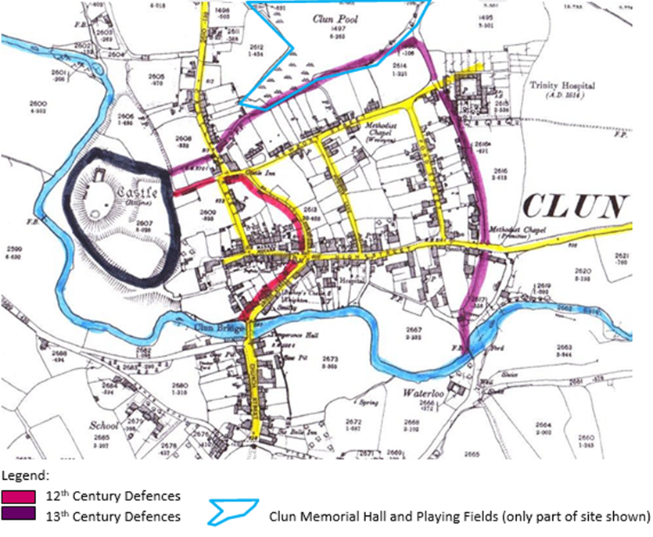

Figure 2: Map taken form Tina Andrew’s MA Thesis, showing suggested circuits of medieval defences relating to the site.

Clun Mill 1650s to 1926. Tony Martyr’s research indicates that as farming improved, and the pond was no longer primarily a source of winter protein, its water was used to drive the water-wheel and machinery of Clun Mill, just to the east of the site. What is now Clun Youth Hostel was once a flour and bran mill. Tony Martyr cites an 1850 document which refers to the water wheel of the time being a “cumbrous device of some 200 years standing" which would place the earliest reference to the mill in the 1650s and coincide with the decline of the castle estate.
According to the Historic England website (https://historicengland.org.uk/listing/the-list/list-entry/1054460), the current mill was built in the early 1800s, and then extended and re-equipped in the mid-19th century by John Poundley, the engineer responsible for work on the Leighton Estate (Montgomeryshire). The mill formerly had an external overshot paddle wheel to the south-east, but in 1851-2 the water wheel mechanism was replaced by a water turbine. The turbine is a Whitewall & Stirrat machine, made in Glasgow, and is a very rare survivor of a type of machine that bridges the time gap in the Industrial Revolution between the medieval water wheel and the advent of the electric motor. The mill ceased working in 1926.

Clun Lake
Eric Tudor recorded in a 1998 document talks about going skating and fishing at Clun Lake. We will build on this information and do further research.

Clun Tip: Shropshire Council holds a plan dated August 1921 that grants William Jones the right to deposit refuse at Clun Pool. This shows that the eastern end of the site, where the bike park and playground currently stand, was being used as a rubbish tip at least from this time. The refuse is likely to have been deposited onto marshy ground, according to the markings on historic maps. This is supported by the recollections of Eric Tudor, recorded in a 1998 document held by Clun Museum: “In line with the path from Newport Street, joining up with Jim Cooke’s Field, there was a hedge and fence, this divided the rubbish tip from the lake”.

From the recollections of Eric Tudor it is also known that the rubbish of Clun was deposited in the tip along with spoil from improvements to the road between the top of Colstey Bank and Colebatch. It was not a pleasant state of affairs: “The rubbish was to fill the stagnant pool; having no sewerage scheme the drains of Castle Street and Newport Street went into the pool and stank. The tip soon became overrun with rats … The smell of fires burning under the ground stopped us from opening our back bedroom windows.”

Leisure Plan 1947. According to the recorded recollections of Eric Tudor and Ronnie Middleton, held by Clun Museum, an attempt was made to dredge the lake in 1947. Eric recalled that “the owners had visions of pleasure boats and a café” and Ronnie recalled buckets strung on wires were drawn between two steam engines, in order to “scoop out the mud from the bottom”. Unfortunately, this damaged the clay lining of the lake, causing most of it to drain. Ronnie Middleton also recalled: “Days later hundreds of fish were left thrashing around near the sluice, in the last drop of muddy water, huge pike and lots of other types of fish. Most of all I remember the terrible smell of rotting fish weeks later”. This attempt to improve the lake was never completed. Eric Tudor recalls that “sadly one of the partners died and the whole project stopped, leaving the dried-up lake derelict for some years”. The site seems to have then became a much smaller remnant lake in the existing hollow, probably seasonal in nature, with the rubbish dump then extended to fill the area now occupied by the football pitch. Eric Tudor recalled: “The tip closed in approximately 1965 … They levelled the tip with a bulldozer, this is now the playing field”

Clun Memorial Hall and Playing Fields. In the early 1970s Clun Town Council with Chapel Lawn purchased the site. A Charity known as Clun and District Playing Fields, was then formed on the 10th April 1972 to own and manage the site. A second charity, the New Memorial Hall Trust, was formed on the 28th October 1977 to oversee the development, building and management of the hall which was granted planning permission on 30th July 1976 and officially opened on the 15th September 1979. These two charities were merged in 1991 to form the Clun Memorial Hall and Playing Fields Charity which has owned and managed the hall and its land to this day.

Clun Wildlife Pool Project was formed in 1999 with the aim to partially restore the lake to provide an amenity and wildlife site. By this time the remaining pool appears to have become seasonal in nature. The plan was to re-line the pool with clay and to fill it in summer via a borehole. The project reached an advanced stage but encountered various funding setbacks and ceased in 2003. The documentation and research of the Clun Wildlife Pool Project on the history of the site has been of immense value for our research.

Hazards, constraints and threats

Former landfill site
The former South Shropshire District Council identified the former Clun Pool as a landfill site and therefore as potentially contaminated land in a file dating from 1991. The file only contains a reference to the parts of the tip levelled when the Memorial Hall was built and a very basic desk-based risk assessment that suggested remedial action is not considered necessary.

In terms of potential environmental risks, these have not been assessed as no site investigation has been carried out and therefore it is impossible to state what the actual level of risk to potential receptors, such as local waterways, would be. However, according to an autumn 2018 email communications from Shropshire Council, there is no information to suggest that any part of the land is not suitable for its current and continuing use at the present time.

Caution is advised regarding growing plants to provide food (e.g. on allotments).

Tree safety
Managing the risk from trees is the responsibility of the owners and managers of the land on which they grow. Human safety is just one part of that management. Risk management can be undertaken only by understanding the trees and their value to people in the context within which they grow. The requirement under health and safety legislation is to have a suitable and sufficient risk assessment, and to apply measures that are reasonable and practicable.

The importance of tree safety is increased significantly as Ash dieback disease has taken hold. Given the prevalence of ash on the site, this will have a significant impact over the next decade. The general consensus is to retain ash where possible but the condition of infected trees and the risk they may pose to site users may preclude this approach on this site.

Further steps need to be taken to ensure a suitable and sufficient risk assessment is in place and that reasonable and practicable measures have been applied. This needs to be regularly updated.

Clun Space March 2019 Please note more information is available on request.

